- Tên và phân loại:

- Mục đích, ý nghĩa:
- Define the skeleton of an algorithm in an operation, deferring
some steps to subclasses
- Lets subclasses redefine certain steps of an algorithm without
changing the algorithm's structure
- Động lực sử dụng:
- Sometimes you want to specify the order of operations that a method
uses, but allow subclasses to provide their own implementations of
some of these operations.
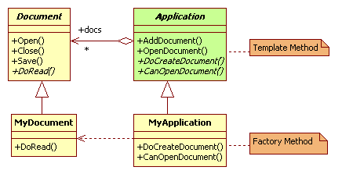
- Khi nào sử dụng:
- To implement the invariant parts of an algorithm once and
leave it up to subclasses to implement the behavior that can
vary
- When common behavior among subclasses should be
factored and localized in a common class to avoid code
duplication
• You first identify the differences in the existing code and then
separate the differences into new operations
• Finally, you replace the differing code with a template method
that calls one of these new operations
- To control subclasses extensions. You can define a template
method that calls "hook" operations at specific points, thereby
permitting extensions only at those points
- Cấu trúc
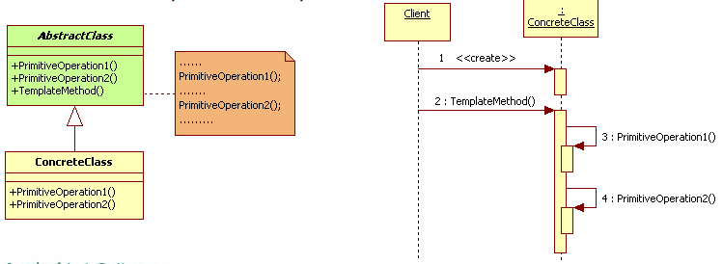
- Các thành viên - Sự cộng tác
- AbstractClass
• Defines abstract primitive operations that concrete subclasses
define to implement steps of an algorithm
• Implements a template method defining the skeleton of an
algorithm. The template method calls primitive operations as well
as operations defined in AbstractClass or those of other objects
- ConcreteClass: implements the primitive operations to carry
out subclass-specific steps of the algorithm
- Các hệ quả mang lại:
- Are a fundamental technique for code reuse
• They are particularly important in class libraries, because they are
the means for factoring out common behavior in library classes
- Lead to an inverted control structure that's sometimes referred
to as "the Hollywood principle," that is, "Don't call us, we'll call
you“
• This refers to how a parent class calls the operations of a subclass
and not the other way around
- Chú ý liên quan đến cài đặt:

- Hệ thống thực tế

- Mẫu liên quan
- Factory Methods are often called by template methods
- Strategy: Template methods use inheritance to vary part of an
algorithm. Strategies use delegation to vary the entire
algorithm

